KEYBOARD
The invention of the modern computer keyboard began with the invention of the typewriter. Christopher Latham Sholes patented the typewriter that we commonly use today in 1868. The Remington Company mass marketed the first typewriters starting in 1877.
A typewriter by definition is a small machine, either electric or manual, with type keys that produced characters one at a time on a piece of paper inserted around a roller. Typewriters have been largely replaced by personal computers and home printers.

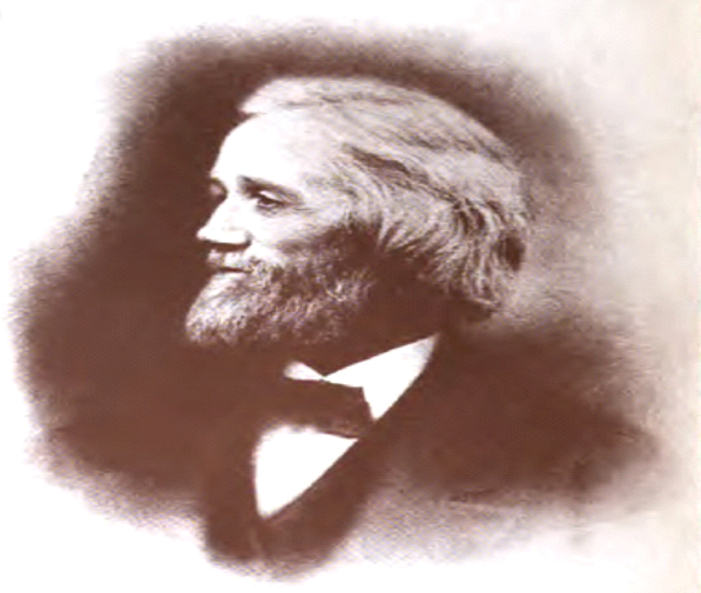

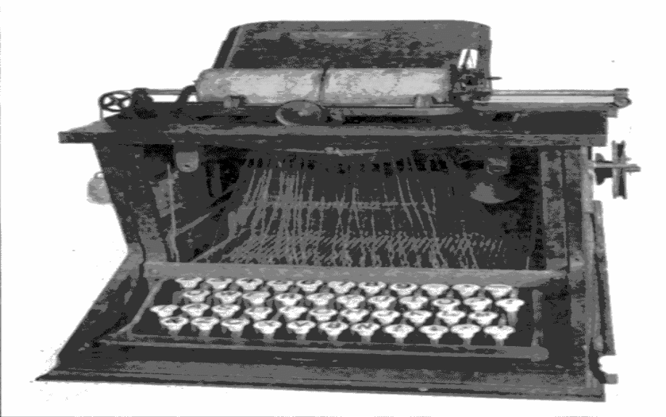

In the 1870s,Christopher Latham Sholes created the First typewriter.
3 5 7 9 N O P Q R S T U V W X Y Z
2 4 6 8.A B C D E F G H I J K L M
It's look like this.
It worked but typewriter's had a big flaw.....
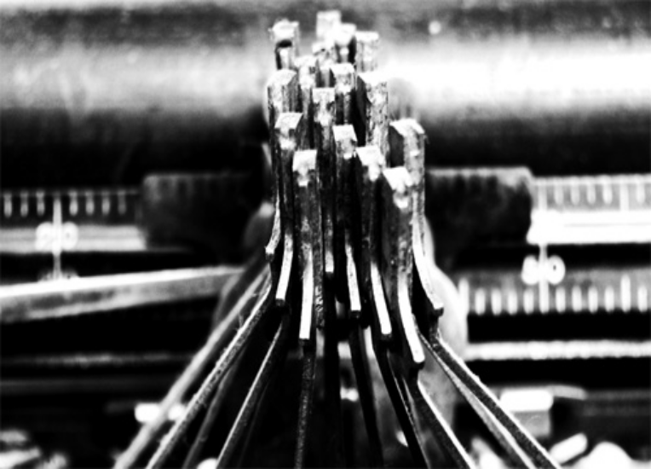
A typewriter by definition is a small machine, either electric or manual, with type keys that produced characters one at a time on a piece of paper inserted around a roller. Typewriters have been largely replaced by personal computers and home printers.
Christopher Sholes
Christopher Sholes was an American mechanical engineer, born on February 14, 1819 in Mooresburg, Pennsylvania, and died on February 17, 1890 in Milwaukee, Wisconsin. He invented the first practical modern typewriter in 1866, with the financial and technical support of his business partners Samuel Soule and Carlos Glidden. Five years, dozens of experiments, and two patents later, Sholes and his associates produced an improved model similar to today's typewriters.


The first electric typewriter was the Blickensderfer. In 1944, IBM designs the first typewriter with proportional spacing. Pellegrine Tarri made an early typewriter that worked in 1801 and invented carbon paper in 1808. In 1829, William Austin Burt invents the typographer, a predecessor to the typewriter.
A few key technological developments created the transition of the typewriter into the computer keyboard. The teletype machine, introduced in the 1930s, combined the technology of the typewriter (used as an input and a printing device) with the telegraph. Elsewhere, punched card systems were combined with typewriters to create what was called keypunches. Keypunches were the basis of early adding machines and IBM was selling over one million dollars worth of adding machines in 1931.
Early computer keyboards were first adapted from the punch card and teletype technologies. In 1946, the Eniac computer used a punched card reader as its input and output device.
The first typewriter to be commercially successful was invented in 1868 by Americans Christopher Latham Sholes, Frank Haven Hall, Carlos Glidden and Samuel W. Soule in Milwaukee, Wisconsin, although Sholes soon disowned the machine and refused to use, or even to recommend it.
What's under the keys?
What's under the keys?
What's under the keys?

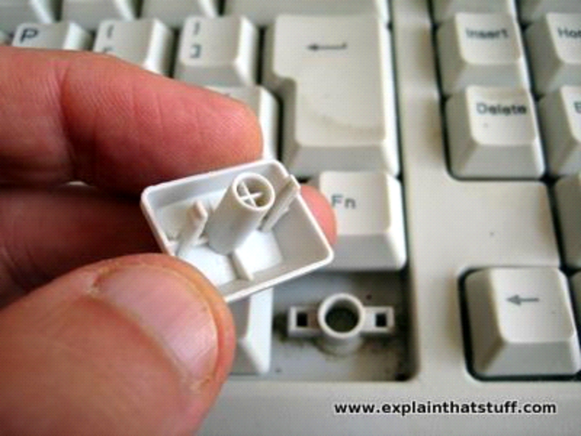

Pull a key off the keyboard and you can see roughly how it works. There's a little hole in the plastic base and the keyboard has a long round bar the same shape. When you press the key, the bar pushes down through the hole to touch the contact layers below. Inside the hole, there's a little tiny piece of rubber (you can't see it in this photo) that stops the key moving down and pushes it back up when you release it. This is what gives the spring to the keys.
2. What's under the keyboard?

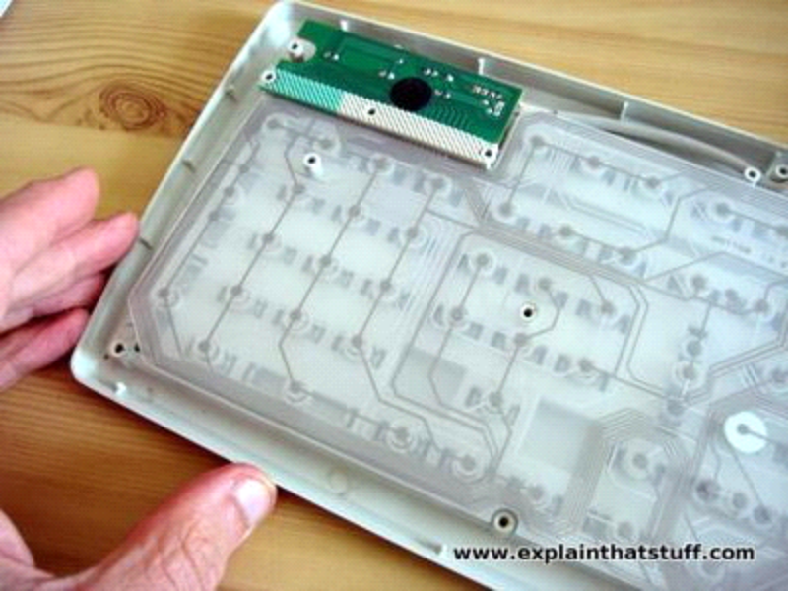

ottom of the keys and where they press down. Balancing on my fingertip, you can see oTake off the keyboard's bottom panel and you can see how it all works from beneath. You can see the transparent plastic contact layers that detect key presses and (through those layers) you can see the round bars poking the keys down from above. The green rectangle at the top contains three small LEDs that activate the indicator lights for "Num lock", "Caps lock", and "Scroll lock". Notice also the cable running along the inside of the case at the top of the keyboard, which carries electrical signals from the keyboard to your computer's USB port (or PS/2 port on older machines).
3. How do the keys press down?

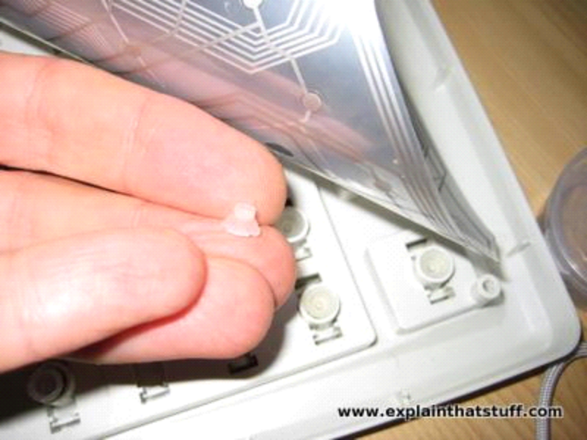

Peel back the electrical contact layers and you can see the bne of the little rubber pieces that makes the keys bounce up and down. Notice the pattern of electrical tracks on the contact layers. In this photo, we are looking down through the bottom of the keyboard (so the keys are underneath).
4. How do the contact layers work?

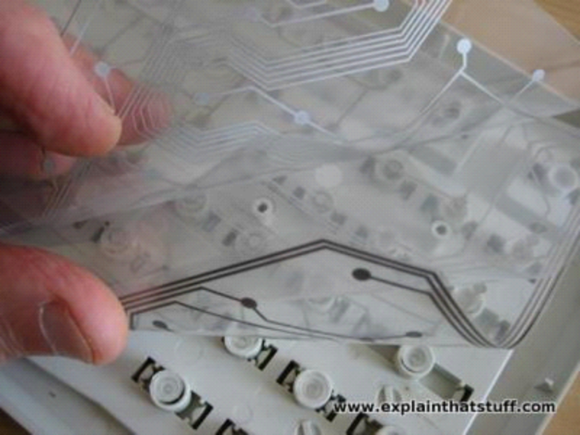

This is the magic part of a keyboard. There are three separate layers of plastic that work together to detect your key presses. Two of them are covered in electrically conducting metal tracks and there's an insulating layer between them with holes in it. The dots you can see are places where the keys press the two conducting layers together. The lines are electrical connections that allow tiny electric currents to flow when the layers are pressed tight to one another by a key moving down from above.
In the photo below, you can see a closeup of the underside of one key—and, if you look closely, just about see how it works. There's one set of electrical connections on the lower sheet of plastic, printed in light gray. The other set is on the upper sheet of plastic and printed in dark gray. The two sheets are kept apart by a clear plastic layer except at the holes, which is where the keys push down to make the two sheets touch.
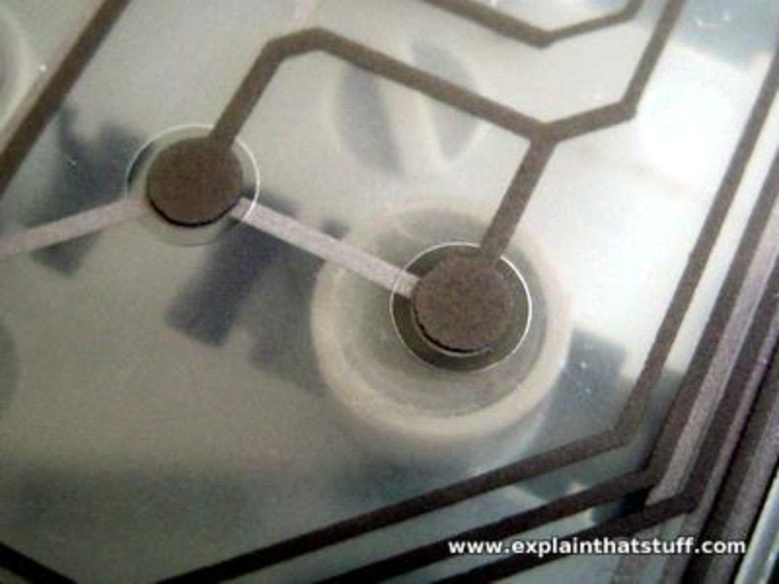

5. How does it all work together?
When you press a key, the top and bottom contact layers come together and the keyboard sends a signal to your computer—just like this...

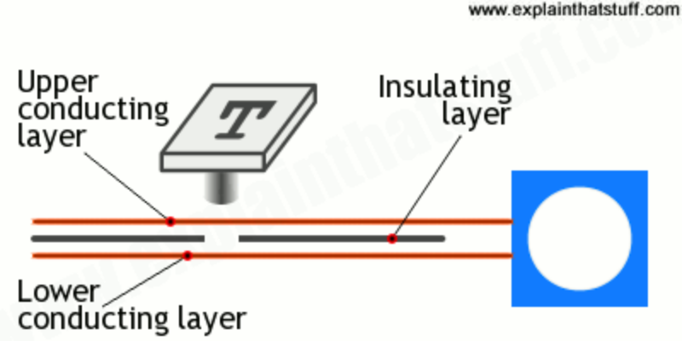
No keyboards were harmed during the making of this article. Well, not much. Oh okay, just a little bit, but they still work fine.
Description of keyboard
A computer keyboard is an input device used to enter characters and functions into the computer system by pressing buttons, or keys. It is the primary device used to enter text. A keyboard typically contains keys for individual letters, numbers and special characters, as well as keys for specific functions. A keyboard is connected to a computer system using a cable or a wireless connection.
Typical keyboard for a desktop computer
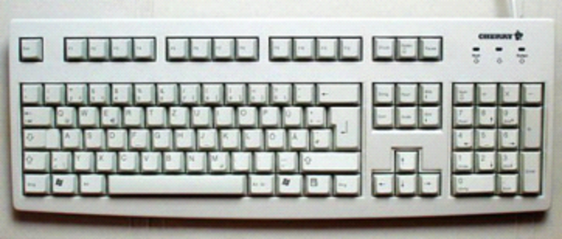
Most keyboards have a very similar layout. The individual keys for letters, numbers and special characters are collectively called the character keys. The layout of these keys is derived from the original layout of keys on a typewriter. The most widely used layout in the English language is called QWERTY, named after the sequence of the first six letters from the top left.
Other sets of keys common to almost all keyboards are entering and editing keys (e.g., Enter, Delete, Insert), modifier keys (e.g., Control, Shift), navigation keys (e.g., arrows for up, down, left, right) and lock keys (e.g., Caps Lock). Additional keys are very operating system specific (such as the Windows and Apple keys).
Most keyboards also include a set of function keys at the top (F1, F2, etc.). The function keys typically perform a very specific task within a particular software application. So, what they do may depend on what you are doing on your computer at the time.
Most keyboards for desktop computers also contain a separate numeric keypad to the right. Even though there are numeric keys already in a row near the top, having them all close together makes it faster to enter numeric data. On smaller keyboards, like those on most laptops, these numeric keypads are typically no longer present due to space constraints.
Here you can see a typical keyboard layout. Keep in mind that there are many different variations on this layout, although most manufacturers follow this general pattern:
Standard layout of keys
How many keys are on a computer keyboard?
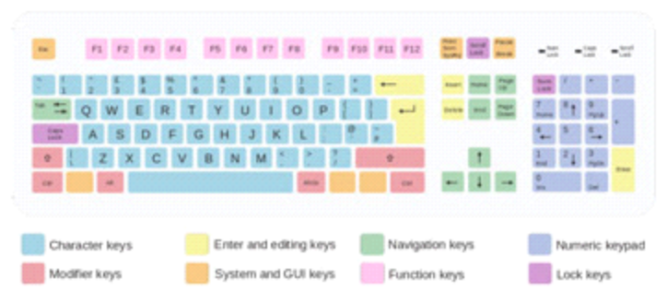
However, this general layout has remained remarkably unchanging over the years. This has made it easy for users to transition from one computer system to the next and to use their typing skills on multiple devices.
For many tasks, you need to press more than one key at the same time. For example, to get a capital letter 'A' you need to press the Shift key and the A key at the same time. When reading or writing instructions for how to accomplish a particular task, this would be described as 'Shift + A.' As another example, in most software applications, Ctrl + S means to save the current document. If you have been using computers for some time, you are probably familiar with a number of such combinations.
Want to know the most famous combination of all? Ctrl + Alt + Del, also referred to as Control-Alt-Delete. In older computer systems, this actually rebooted your computer. Sort of like pulling the power cord and plugging it back in again. In more modern versions of the Windows operating system, the combination brings up options to log off or shut down, as well as options to force a particular software application to quit. This is useful if you are not able to exit an application in a regular fashion.

How many keys are on a computer keyboard?
Although there is not a single set of rules dictating the number of keys on a keyboard, most companies use the PC keyboard with 104 keys as a de facto standard.

IBM/PC keyboards
- Original IBM PC Keyboard (1981) - 83 keys
- Updated IBM PC Keyboard (1984) - 84 keys
- AT Keyboard - 84 keys
- AT Enhanced Keyboard - 101 keys
- US Traditional Keyboard - 101 keys
- Enhanced European Keyboard - 102 keys
- Windows Keyboard - 104 keys
- Windows-based Laptop Keyboard - 86 keys

Miscellaneous keyboards
Other keyboard configurations may include more than 104 keys, mainly being the Korean, Japanese, and Brazilian keyboards. Also, keyboards with keys to control a CD drive and Media Center functionality using special keys may have several dozen additional keys. Other keyboards provide programmable keys and may fall into the category of a programmable or gaming keyboard.
Computer keyboard key explanations

Many times, this can be confusing for anyone unfamiliar with each of the symbols on a keyboard. The table below identifies non-alphanumeric keys with a description or link for additional information.

Key/Symbol | Explanation
Windows | PC keyboards have a Windows key that looks like a four-pane window
Command | Apple Mac computers have a command key.
Menu | PC keyboards also have a Menu key that looks like an cursor pointing to a menu.
Esc | Esc (Escape) key
F1 - F12 | Information about the F1 through F12 keyboard keys.
F13 - F24 | Information about the F13 through F24 keyboard keys.
Tab | Tab key
Caps lock | Caps lock key
Shift | Shift key
Ctrl | Ctrl (Control) key
Fn | Fn (Function) key
Alt | Alt (Alternate) key (PC Only; Mac users have Option key)
Spacebar | Spacebar key
Arrows | Up, Down, Left, Right Arrow keys
Back Space | Back space (or Backspace) key
Delete | Delete or Del key
Enter | Enter key
Prt Scrn | Print screen key
Scroll lock | Scroll lock key
Pause | Pause key
Break | Break key
Insert | Insert key
Home | Home key
Page up | Page up or pg up key
Page down | Page down or pg dn key
End | End key
Num Lock | Num Lock key
~ | Tilde
` | Acute, Back quote, grave, grave accent, left quote, open quote, or a push
! | Exclamation mark, Exclamation point, or Bang
@ | Ampersat, Arobase, Asperand, At, or At symbol
# | Octothorpe, Number, Pound, sharp, or Hash
£ | Pounds Sterling or Pound symbol
€ | Euro
$ | Dollar sign or generic currency
¢ | Cent sign
¥ | Chinese/Japenese Yuan
§ | Micro or Section
% | Percent
° | Degree
^ | Caret or Circumflex
& | Ampersand, Epershand, or And
* | Asterisk and sometimes referred to as star.
( | Open parenthesis
) | Close parenthesis
- | Hyphen, Minus or Dash
_ | Underscore
+ | Plus
= | Equal
{ | Open Brace, squiggly brackets, or curly bracket
} | Close Brace, squiggly brackets, or curly bracket
[ | Open bracket
] | Closed bracket
| | Pipe, Or, or Vertical bar
\ | Backslash or Reverse Solidus
/ | Forward slash, Solidus, Virgule, or Whack
: | Colon
; | Semicolon
" | Quote, Quotation mark, or Inverted commas
' | Apostrophe or Single Quote
< | Less Than or Angle brackets
> | Greater Than or Angle brackets
, | Comma
. | Period, dot or Full Stop
? | Question Mark
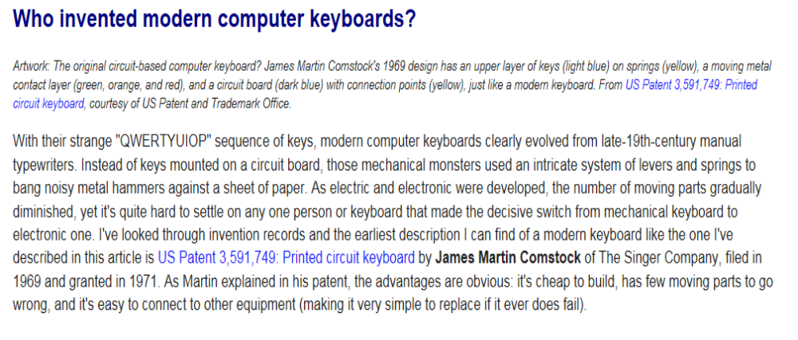Types of Keyboard:-
MULTIMEDIA
For the people who are much into multimedia designing. This keyboard is just like the standard key board, but composed of additional keys for the multimedia purposes such as multimedia applicThe multimedia keyboard is specially designed ation launch, volume control and mute button.

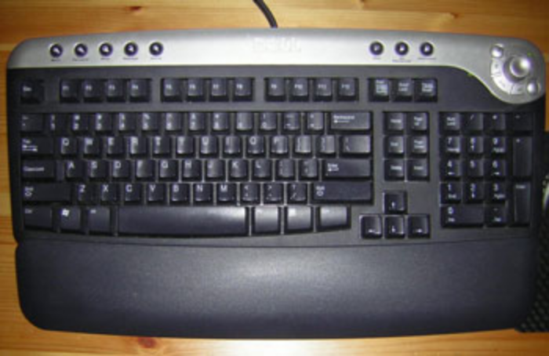

INTERNET
The Internet keyboards are designed for wider range of multimedia applications, these keyboards are specially designed for the intense Internet user. The special keys included in this keyboard are the home key, back and forward key, e-mail launch key, and browser launch key etc. these keys carry out the same functionality as of the buttons on the webpage. In order use these extra keys the computer must be embedded with right operating system.
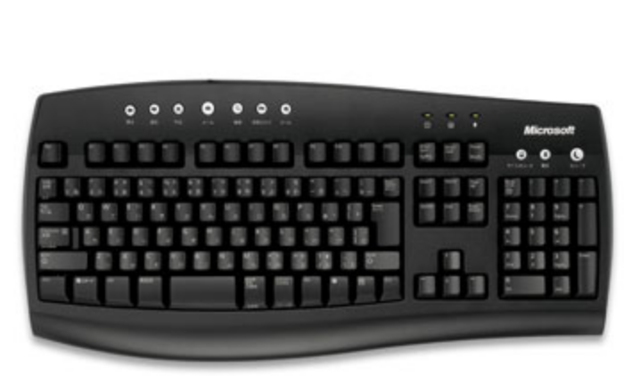

WIRELESS
A wireless keyboard, the name itself doles the meaning that this keyboard can be operated without addressing a wired connection to the processor. The wireless keyboards are also referred as Cordless keyboards; these keyboards require batteries to provide the electricity which usually delivered through a PS/2 or USB cable. “AA” or “AAA” batteries are most widely used standard batteries for wireless keyboards. Apple Macs are known to revolutionize the wireless keyboard by making them thinner than the wired ones. These keyboards usually work at 2.4 GHz frequency and come with a dongle that connects and makes them communicate with the computer.
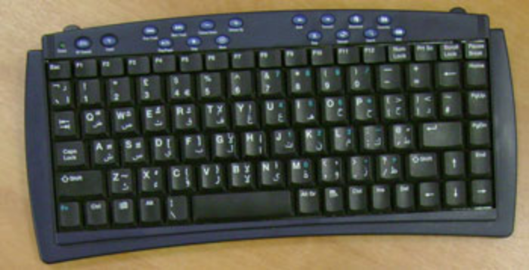
GAMING
As the name suggest, gaming keyboards are those who are into gaming and need easy access to the keys that are usually utilized in gaming. These keyboards are composed of particular gaming-oriented features such as key lighting, programmable keys, and/or extra controls of volume and brightness. These keyboards are available in wired and wireless, in case if wired, it usually supports the USB port.

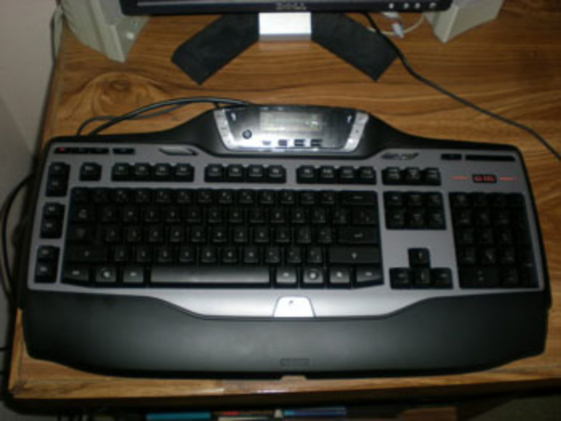

MEMBRANE
Membrane keyboards are one of the keyboard types, which are used very rarely. The keys integrated in this keyboard are non-moving pressure-sensitive keys. The keys in this keyboard are so close, so that there is no scope for spilling liquids into the keyboard. Such keyboard types are also used in mobile phones and old landline phones.

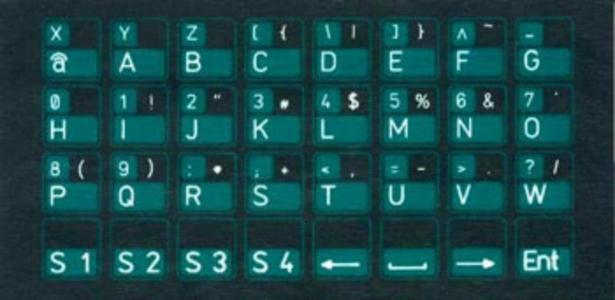
Keyboards are slowly being incorporated into touch screens that are being widely incorporated in various phones and tablet computers. Named as touch screen keyboards, these are virtual keyboard units have a QWERTY and numeric appearance so that message typing and number calling are quite easy. Also, gaming consoles that provide social networking such as the PlayStation 3 have an on-screen keyboard which can be accessed by user joystick.
Compact Keyboard:
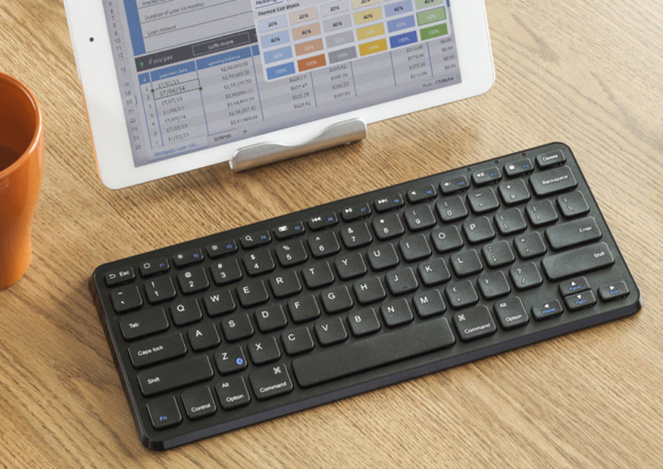

Compact keyboards are not extremely small in size,but offer portability during travel and storage another benefit of compact keyboard is that they can be used by people with certain disabilities that hinder them from effectively using hand and finger movements.
Infrared Keyboard(IR):
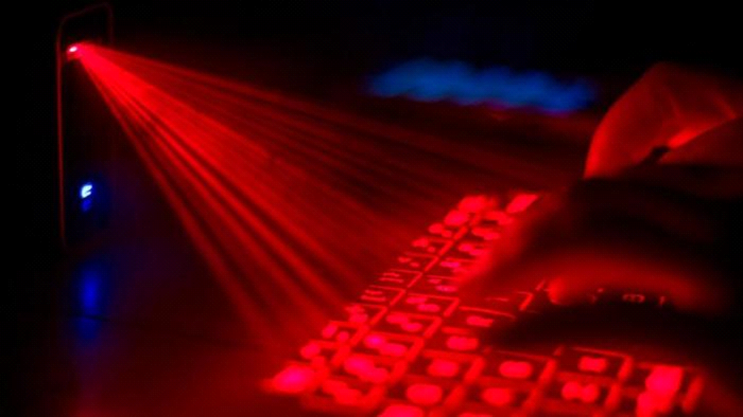

Infrared keyboards have a major drawback.they need to be in the transceiver.this makes it very difficult to use such keyboards effectively,and almost impossible to use mice featuring this technology.
Radio frequency:
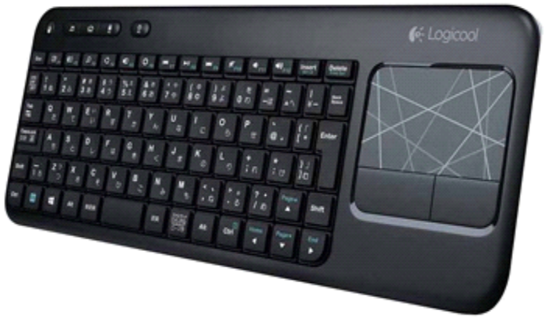

keyboards have a limited range of only about 6 feet,but are much cheaper than bluetooth keyboard,and much more effective than infrared keyboards.
Virtual keyboard:
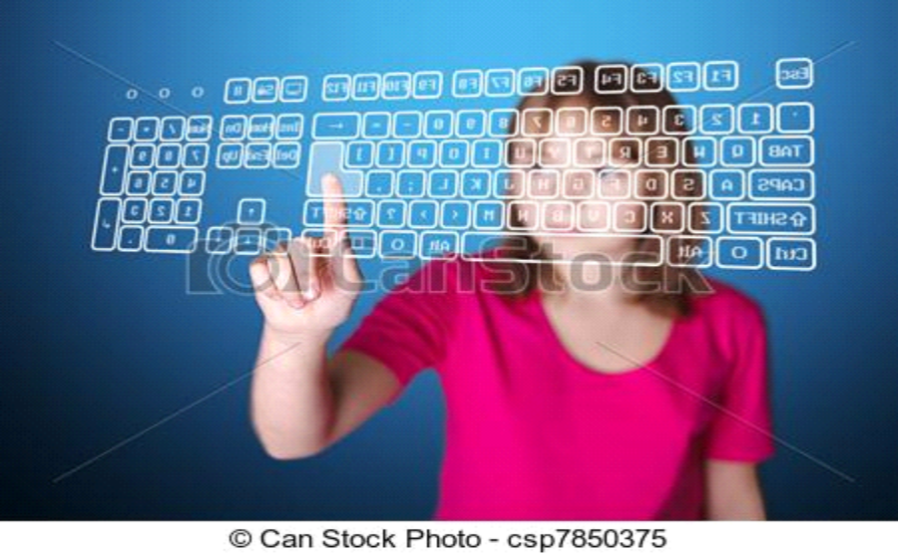

Virtual keyboard are software device that let you input let just like a hardware keyboard.
They open up as an application and can be controlled by a mouse or via a touch screen. they are mainly used in device which do not necessarily required a keyboard,like a tablet or a smart phone.
An introduction to keyboard design theory: What goes where?

Contents

1 Keyboard Layout
2 Large Keyboards
3 Sequence Checking
4 Describing a Keyboard
5 Implementation
6 Conclusion
1 Keyboard Layout
There are two ways of considering the question of adding 'ÿ' to a keyboard.
1.1 Mnemonic
The first way to consider the 'ÿ' is that it consists of two components: 'y' + umlaut. In this case we would have a special keystroke to add the umlaut on top of the 'y', for example the keystroke ¨ following a y might add the umlaut:. In other words we are using existing information on the keys of a users keyboard to help the user remember the keying of the character. We use the term mnemonic keyboard: for this type of keyboard. The SILIPA93 keyboard is of this type. Mnemonic keyboards are commonly used with Latin-based scripts, since there is a close correspondence between what people want to type and what they see printed on the keyboard in front of them.
1.2 Positional
The relative positions of the keys on a qwerty keyboard are defined positionally in relation to each other. Thus it does not matter what is printed on the keytops of the keys, what is important is which key is next to which key on which row. This approach is most commonly used when implementing a keyboard based on a typewriter layout or some other standard. Thus we might consider 'ÿ' as a unit and we might want a single key to press to type this characte
2 Large Keyboards
2.1 Modifier Keys
2.2 Dead keys
2.3 Operator keys
2.4 Candidate Window
3 Sequence Checking
4 Describing a Keyboard

The details of how a keyboarding utility interacts with the system are beyond the scope of this discussion, but there are different ways in which keyboards are described, which are worth examining. There are two dimensions to the issue: what a keyboard is described in terms of and how the rules that go to make up a description interact.
4.1 Types of Rules

A keyboard may be described in terms of keying sequences. For many keyboards, the sequences are of length 1. Thus one keystroke maps to one code input to the application. More sophisticated systems, particularly those based around dead keys, allow a keystroke to change the state of this one to one mapping such that a following keystroke is mapped differently. This is the typical way that a keyboard described in terms of keystrokes, only, is implemented. When the sequence becomes unambiguous, then the utility outputs the corresponding string of codes to the application. Thus, while the keying is ambiguous, then no output is generated. For example, consider a rule-based language with the following rules. Each rule consists of a sequence of keystrokes (and not a keystroke in previous output context).

y -> y
y " -> ÿ
y ' -> _
y @ -> ( y )
5 Implementation
5.1 Mac OS

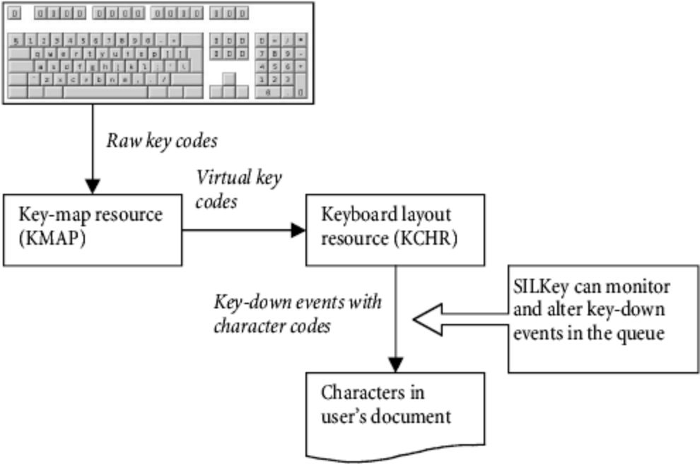
Figure 1: From keystroke to character in the 8-bit world
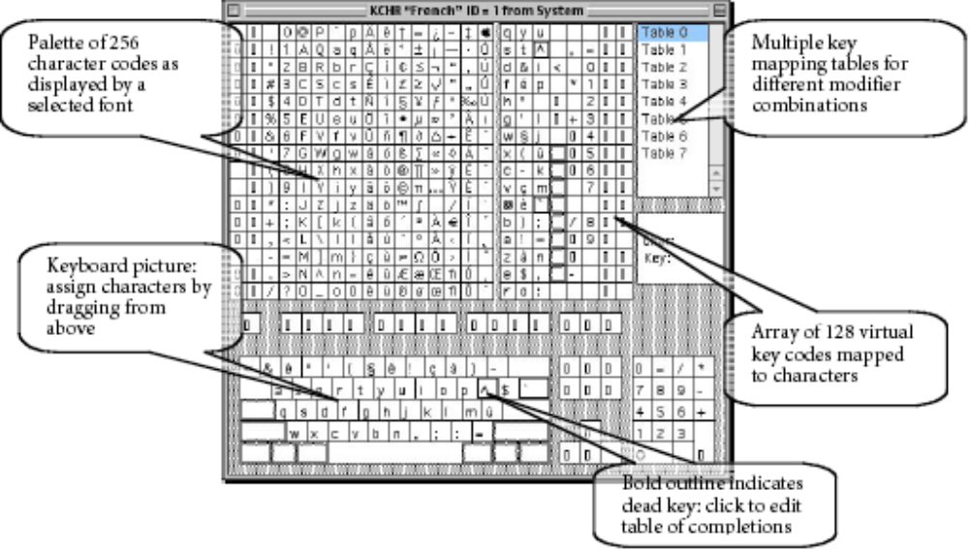
5.2 Windows
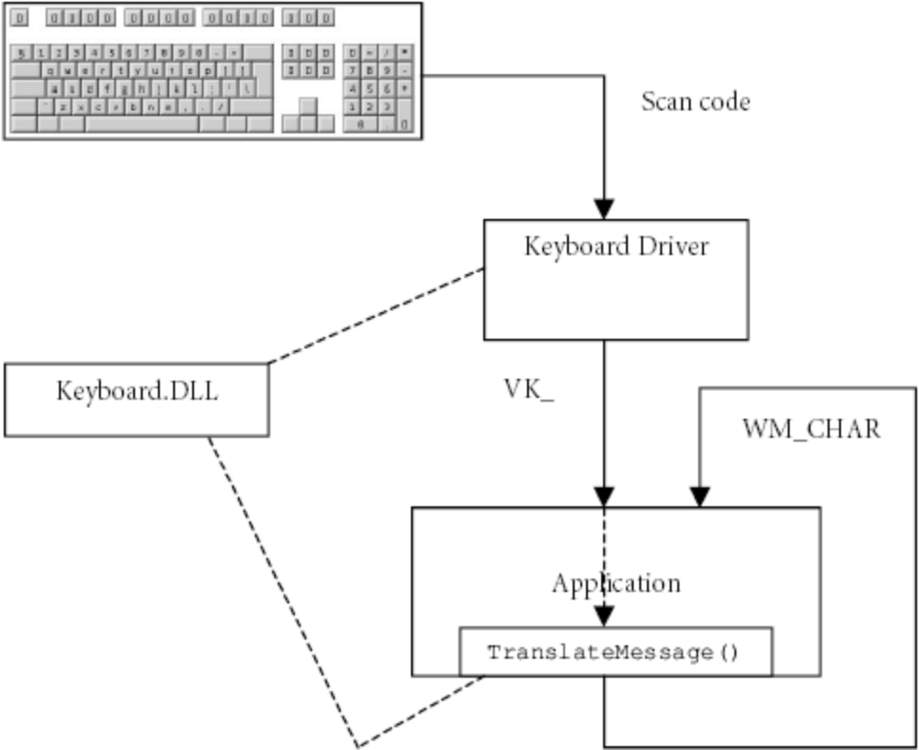

Figure 4: Windows keyboard handling
6 Conclusion

Different keyboarding requirements require different keyboarding solutions. For some, a simple 1:1 mapping is sufficient. For others, complex in-place editing is needed. Others still require some means of picking from a very long list, and narrowing down that list with each key press. As we have seen, each mechanism requires its own support, and different technologies provide different levels of that support.
One thing that can be noted is that as more of the rendering burden is taken away from the encoding and placed upon the rendering subsystem, the keyboarding description is made easier, since most keying relates more to characters than to glyphs. But not all the complexity is removed. There are some cases where things remain extremely complicated. An example of such complexity is a multi-script encoding where one encoding may be rendered in different scripts. Since the keying is visually motivated, the relationship between keystroke and underlying encoding may not be so straight forward.
conclusion:-
Hence we are understand what is keyboard, how it wil be worked ,what is under the keyboard,different types of keys on keyboard and how it will be designed.

